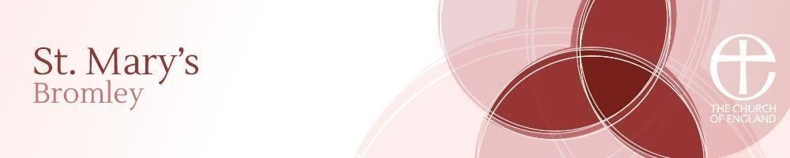
St Mary's Church House and Hall
61 College Road, Bromley, Kent BR1 3QG
Telephone: 07951 748 155

HALL HIRE PRICE LIST 2022
PARTIES

Warwick Hall  (Seats 186 – wooden floor) | £35.00 per hour  (Bouncy castles which would have to be hired from elsewhere, incurs an extra fee of £5.00 per booking)
Buchan Hall  (Seats 60 – wooden floor) | £28.00 per hour
Front Room  (Seats 30 – wooden floor) | £17.00 per hour

Special rates are available for regular hire - please contact us for more information.

